Parallel Programming Lab

Lab 06 – Arhaan Girdhar 220962050

Outputs

Q1.

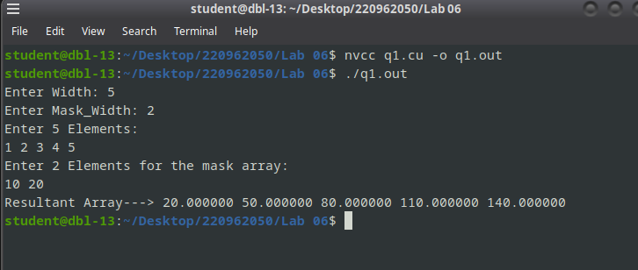

Q2.
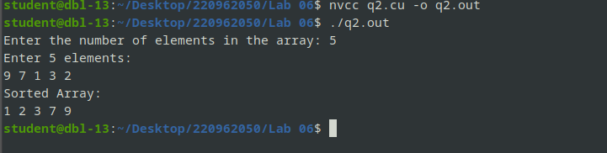

Q3.
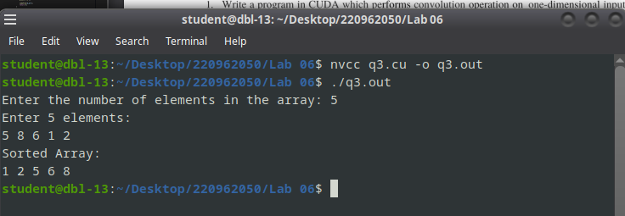

Additional Q1.

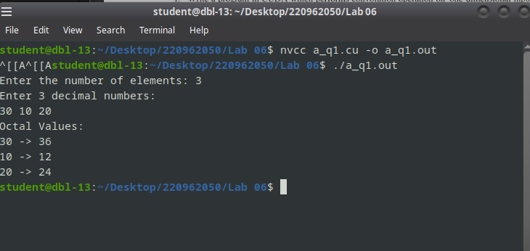

Additional Q2.

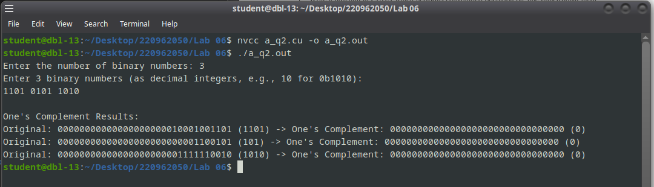

~ END ~

